Report on Online Student Sensitisation Program on SSIP 2.0
- Title of the Program: Student Sensitisation Program on "Problem Identification & Ideation"
- Date: 17 July 2026, 03:00 PM onwards
- Venue: Room No. S11, M. N. College, Visnagar
- Mode of Delivery: Online (MS Teams)
- Resource Person: Ms. Arati Patel, Associate Manager, HE PMU, SSIP 2.0 – KCG
- Organizing Institute: M. N. College, Visnagar
- Objective of the Program
The Student Sensitisation Program was organized with the objective of introducing students to the concept of innovation and entrepreneurship under SSIP 2.0 (Student Startup and Innovation Policy). The session aimed to encourage students to observe real-life problems, develop innovative thinking, and understand the process of converting ideas into viable projects and startups.
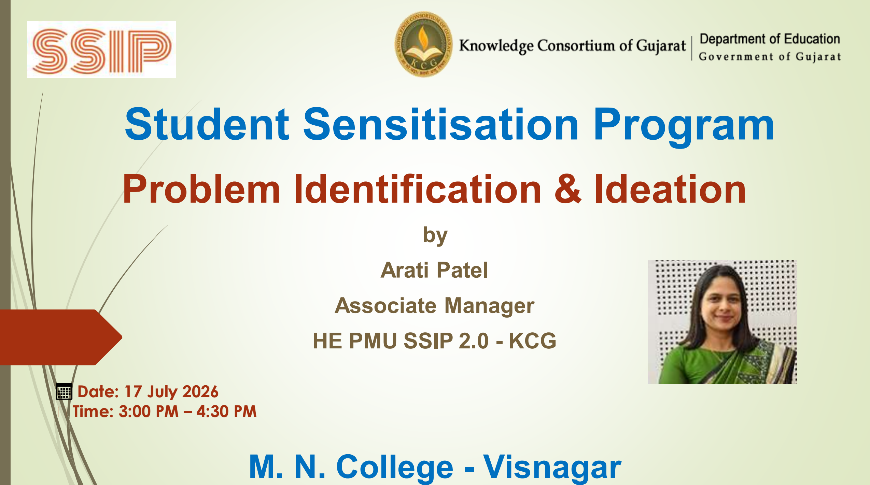
- Program Arrangement
The awareness program was conducted online through Microsoft Teams in Room No. S11. The college established a complete interactive digital setup to ensure effective communication between the expert and the students.
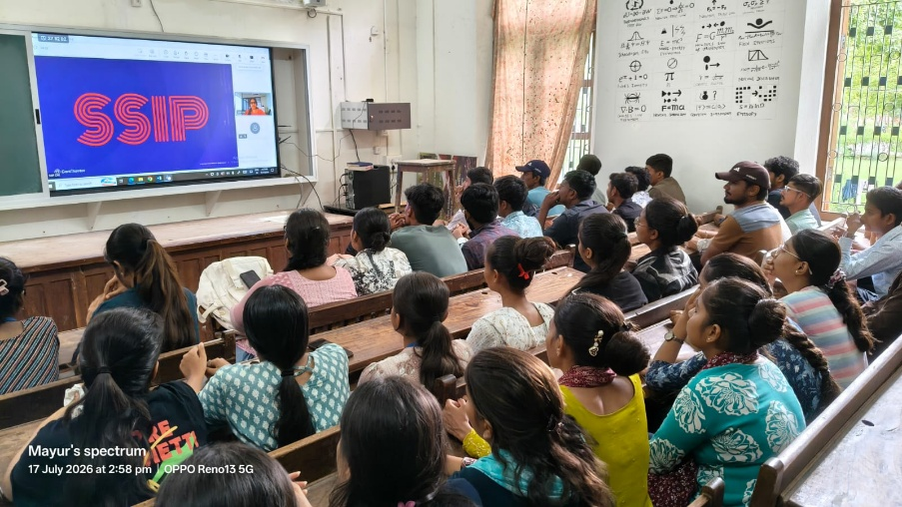
A Smart TV installed in Room No. S11 was used to display the live Microsoft Teams session. A webcam was connected so that the resource person could see the students in the classroom while the students could also interact directly with the expert. This two-way audio and video communication created an engaging classroom environment despite the online mode of delivery. Students were able to ask questions, participate in discussions, and receive immediate responses from the expert, making the session highly interactive and effective.
- Proceedings of the Program
The program commenced at 03:00 PM with the joining of the online session through Microsoft Teams. The resource person, Ms. Arati Patel, Associate Manager, HE PMU, SSIP 2.0 – KCG, delivered an informative and inspiring session on "Problem Identification & Ideation."
The expert explained the objectives of SSIP 2.0 and highlighted the importance of identifying practical problems from daily life, society, agriculture, industry, healthcare, education, and environmental issues. Students were encouraged to cultivate an innovative mindset by carefully observing challenges around them instead of searching for ideas artificially.
The resource person elaborated on the process of transforming a problem into an innovative solution through systematic ideation. Various examples of successful innovations and student-led startup initiatives were discussed to motivate participants. The session also introduced students to the opportunities available under SSIP, including mentoring support, prototype development assistance, financial support, and incubation facilities.
The expert explained each concept in a very lucid and student-friendly manner, making the session easy to understand even for first-time participants. Students actively participated throughout the session and interacted with the expert by asking relevant questions related to innovation, idea generation, startup development, and available SSIP support.

- Participation
The program witnessed enthusiastic participation from undergraduate students of M. N. College, Visnagar. According to the attendance records, a total of 64 students attended the awareness program through the online registration system.
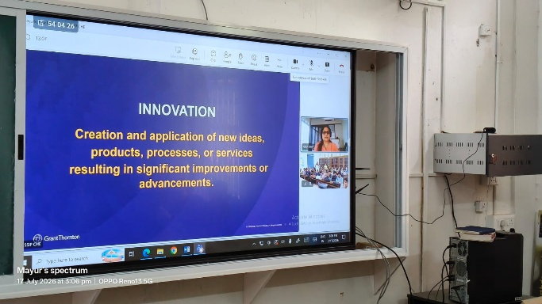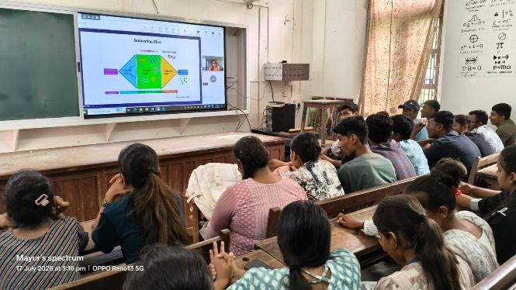
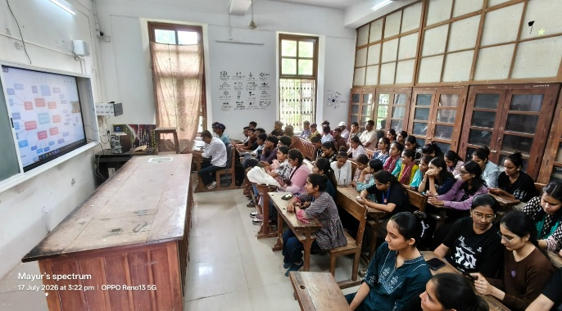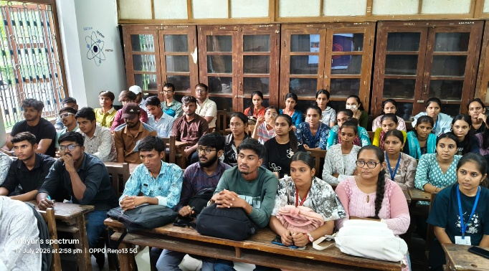
- Outcome of the Program
The awareness program successfully introduced students to the vision and objectives of SSIP 2.0. The session enhanced students' understanding of problem identification, innovation, ideation, and entrepreneurship. Participants became aware of the opportunities available under the Student Startup and Innovation Policy for transforming innovative ideas into practical solutions and startup ventures.
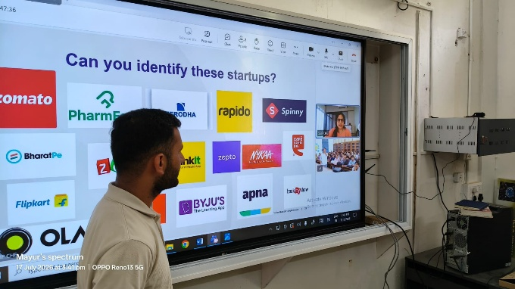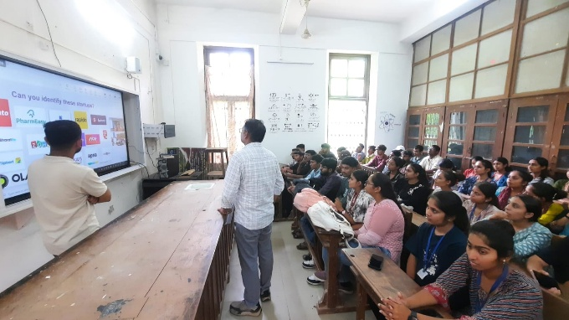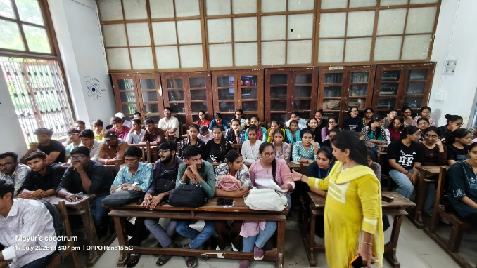
The interactive online arrangement ensured active engagement between the students and the expert, making the learning experience effective and meaningful. The program motivated students to think creatively, identify real-world problems, and participate in future innovation and startup activities organized under SSIP.
- Conclusion
The online awareness program on "Problem Identification & Ideation" proved to be highly informative and inspiring. The well-planned digital infrastructure, including the Smart TV, Microsoft Teams platform, webcam, and two-way communication setup, enabled smooth interaction between the expert and the students. The expert's lucid explanation and practical examples helped students understand the significance of innovation and entrepreneurship under SSIP 2.0. Overall, the program achieved its objectives of sensitizing students towards problem-solving, innovative thinking, and startup culture.

